**GROOVY PROJECTS**

**1. Groovy Script for Log File Analysis.**

**Objective:** The primary objective of this project is to develop an automated Groovy script that can efficiently parse, analyze, and generate insights from server log files. The script will extract key information such as timestamps, log levels, status codes, and messages to provide valuable insights into system performance, error patterns, and request trends.

**Step 1:** Manually Creating a server.log file

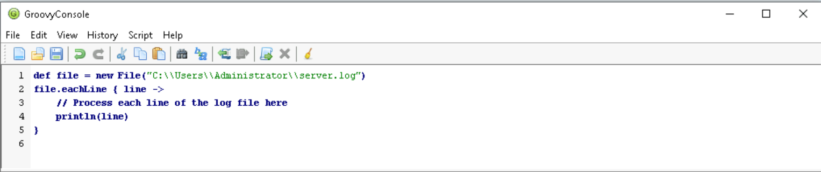

**Step 2:** This reads the log file **line by line** and prints each line

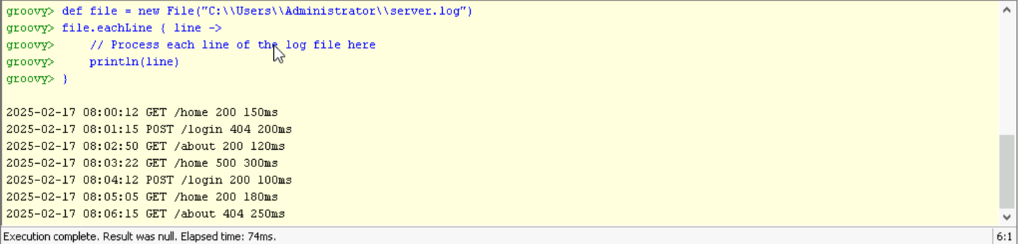

**Step 3:** Using Regex to Extract Timestamp, Status Code and Messages.

We use line =~ regex to match each line with the regex.

If a match is found, it is extracted and stored in the data list.

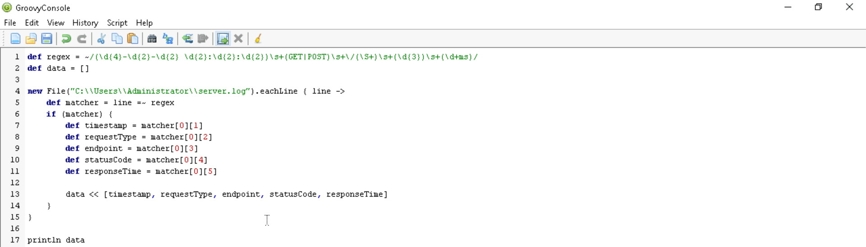

**Step 4:** Aggregate and summarize the data

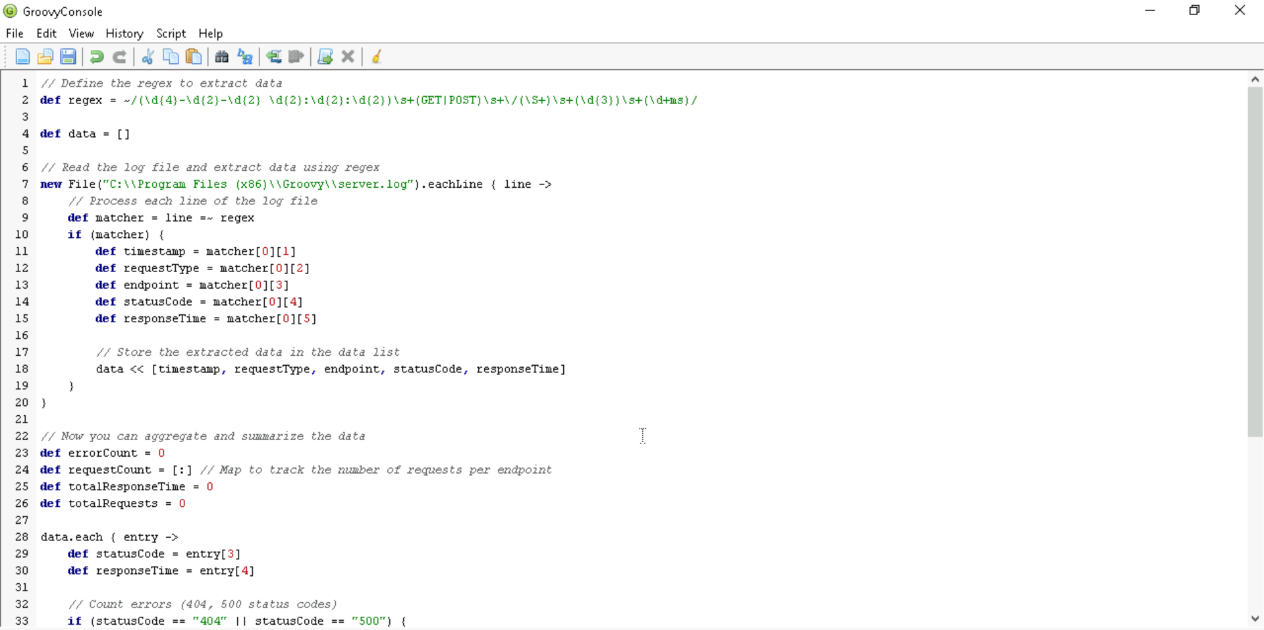

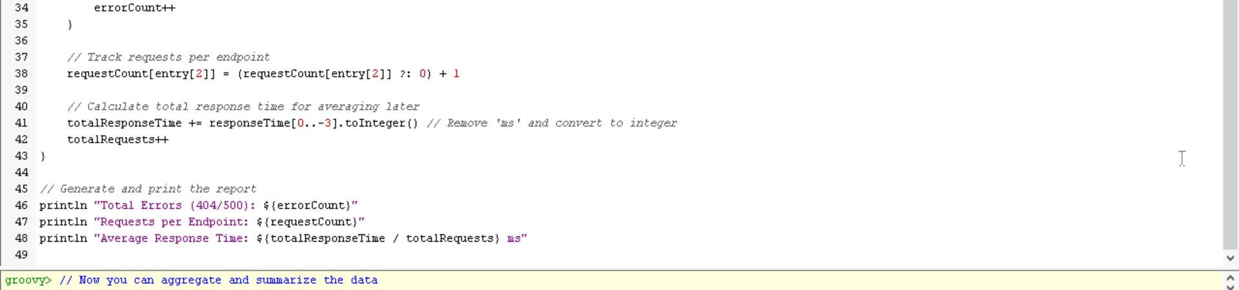

**Step 5:** The Output Shows the Error Count, Response Count, Total Response Time.

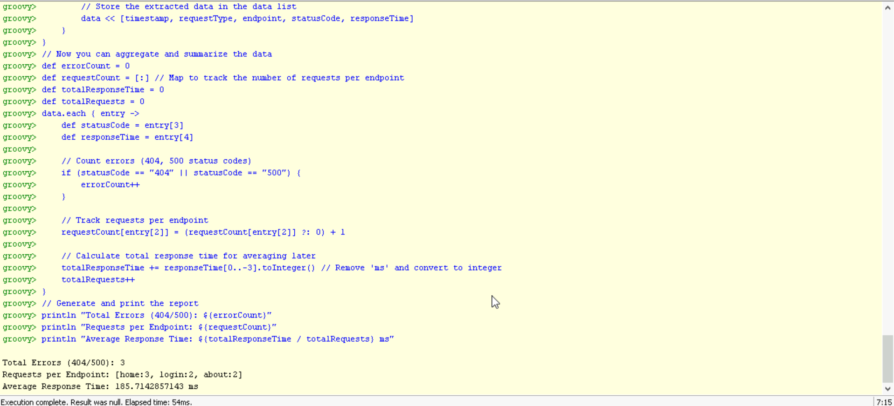

**Step 6:** Creating a Server Log Analysis Report.

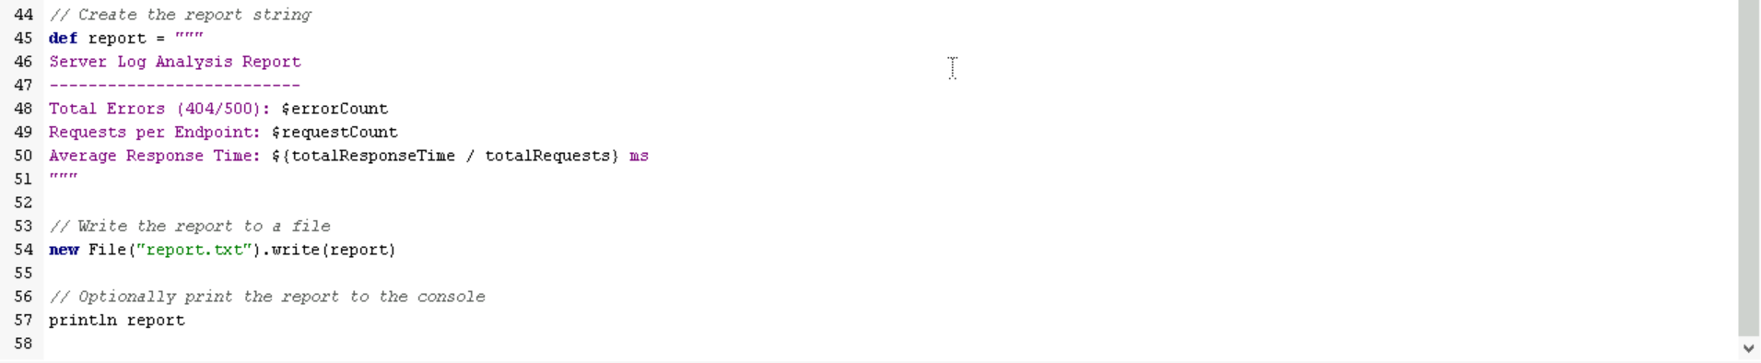

**Conclusion:** This Groovy Script efficiently reads the server log file, extracts relevant data using regular expressions, aggregates the data to provide meaningful insights, and generates a report with error counts, request trends, and response times. This Script can be adapted to different log formats and extended with additional features like visualizing the trends or sending alerts based on specific conditions.